

**CSE 499A Project Report**

Project Topic: Spetial Microphone

Name: Md Mantasarul Elahi

ID: 151 2518 042

Section: 10

GitHub Repository Link: https://github.com/mantasarul4982/Spetial-Microphone

***Content table***

Project Description----------------------------------------------------------------------------------- -------------------Page 3

Application Layout/User Interface-----------------------------------------------------------------------------------Page 4

499A Working Progress-------------------------------------------------------------------------------------------------Page 6

Noise Cancellation With MATLAB------------------------------------------------------------------------------------Page 7

Sound Recorder with Python------------------------------------------------------------------------------------------Page 10

Taking Multiple Audio Input (Microphone/s) and Plotting Graph in Real Time---------------------------Page 11

Graph Output--------------------------------------------------------------------------------------------------------------Page 13

Audio Visualization in CMD using Basic Python-------------------------------------------------------------------Page 14

Graph Output--------------------------------------------------------------------------------------------------------------Page 16

Future Goal----------------------------------------------------------------------------------------------------------------Page 17

Conclusion-----------------------------------------------------------------------------------------------------------------Page 18

***Project Description***

Introduction: This would be an Android based mobile application.

First Approach: At the primitive approach, there would be two cellphones. One would act as a microphone broadcaster. Another one would act as a speaker output.

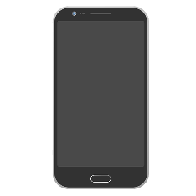 

Broadcaster Receiver

Microphone Speaker

Initially we will test with two android devices. When someone speaks at the Broadcast side, the application would scan via Bluetooth/hotspot technology and automatically connect to the other device which would act as a speaker output. After the first test is successfully done, we would proceed with multiple devices on the Receiver Side. In this case when someone speaks at Broadcaster Microphone side the application would scan for nearby devices and automatically connect to all of them simultaneously.

Second Approach: In this stage a device would take audio with noises from nearby sources and produce better sound quality as output in the other device. Initially it would be done with two devices. Usually modern cellphones have numerous microphones. So, we can assume that a device would take sound input from its microphones and broadcast the sound with better quality audio to a nearby device which would be automatically connected when bought into the range of the broadcasting device. After this approach is successfully done, we can try with numerous android devices which would take audio input simultaneously and broadcast to another android phone. Here the number of cellphones in the receiving side may vary with project progress.

***Application Layout/User Interface***

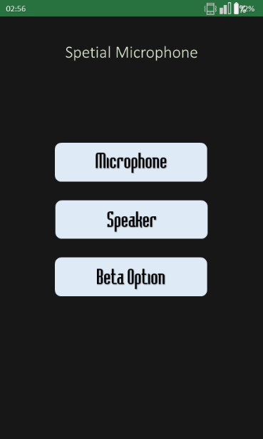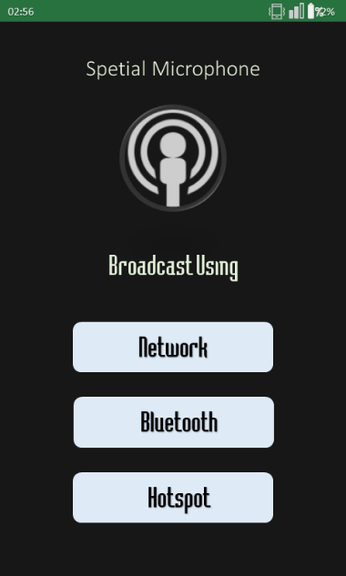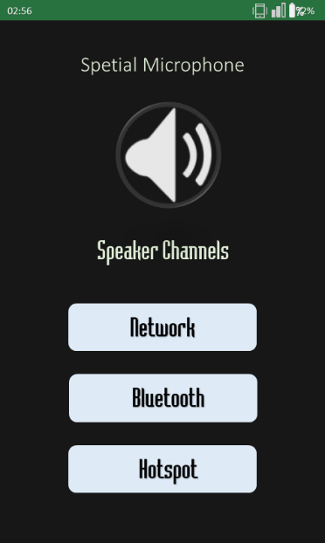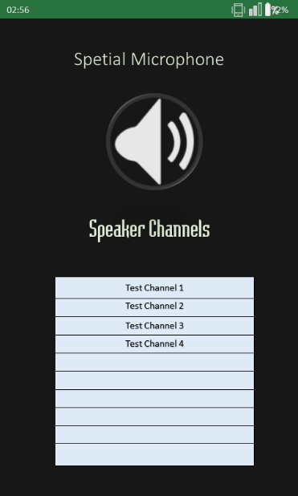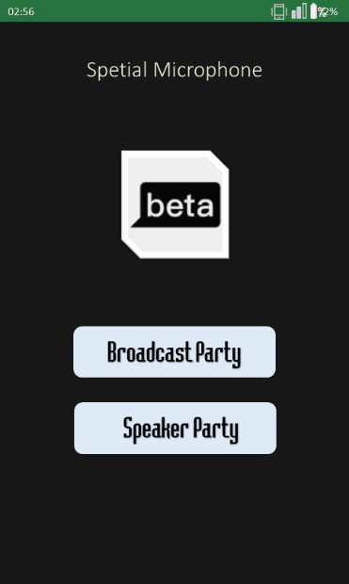

In the first diagram we can see the main menu of the application. Here the user would have option of whether to use the application as a microphone, a speaker or try the beta feature. If the user selects the first option “Microphone”, then the application would move to the next diagram. Here the user would have to select how he/she would like to do the broadcast. There would be three options to choose from. The user can broadcast via the network he/she is signed in to, using Bluetooth technology or by making a hotspot network.

Now if someone is already broadcasting and another user wants to turn his/her device into a loud speaker in order to expand the broadcast range, then the user would have to select the speaker option from the first diagram. It would take the user to the third diagram. Here the interface is similar to the broadcast side. The user would have to select how he/she would like to connect with the microphone. Then in the fourth diagram there would be number of channel’s list in case there are multiple microphones of multiple network. From here the user can select the appropriate one and turn his/her device into a live speaker device streaming live audio output.

In the beta category, the purpose would be the same but instead of only one microphone there would could be numerous microphones and numerous speakers. Now here is the twist. As there would be numerous devices acting as a microphone, the application would take all the audio input in real time and provide with a better-quality audio output to the speaker devices in real time.

***499A Working Progress***

499A was all about researching how to implement the audio processing part of the Beta version. Initial task was to choose which platform would be better to experiment with the audio processing part. Python seemed to have a lot of libraries so I chose Python in order to move on with the idea.

Most of the resources available in online about audio analysis and processing are all done in MATLAB. For audio source comparisons and graph generation MATLAB got most of the resources available. For python huge amounts of audio library are available.

Throughout the entire semester I have gathered resources about the project and my future goal is to properly utilize them all in the upcoming semester break and finish the project. All the gathered resources are given in the following.

***Noise Cancellation With MATLAB***

When audio inputs are taken from two audio sources, one with clear sound another one with noises, the MATLAB code would take both the audio input and filter them out to a clear audible better-quality sound.

Code Snippets:

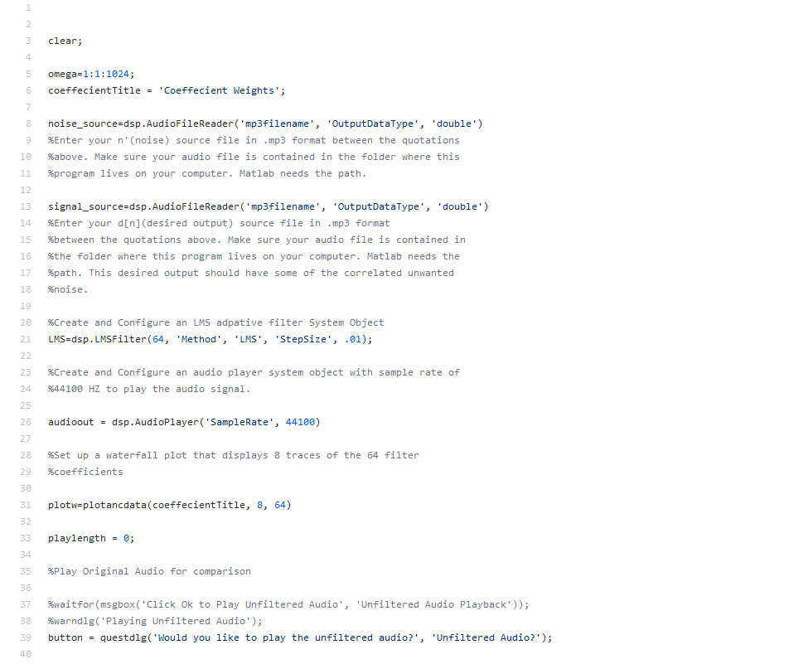

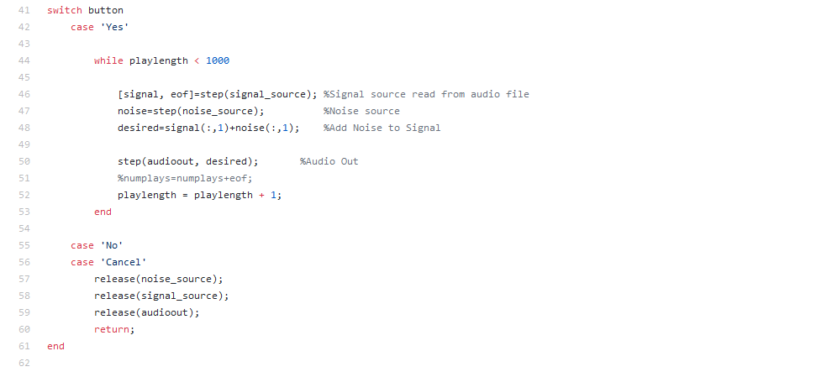

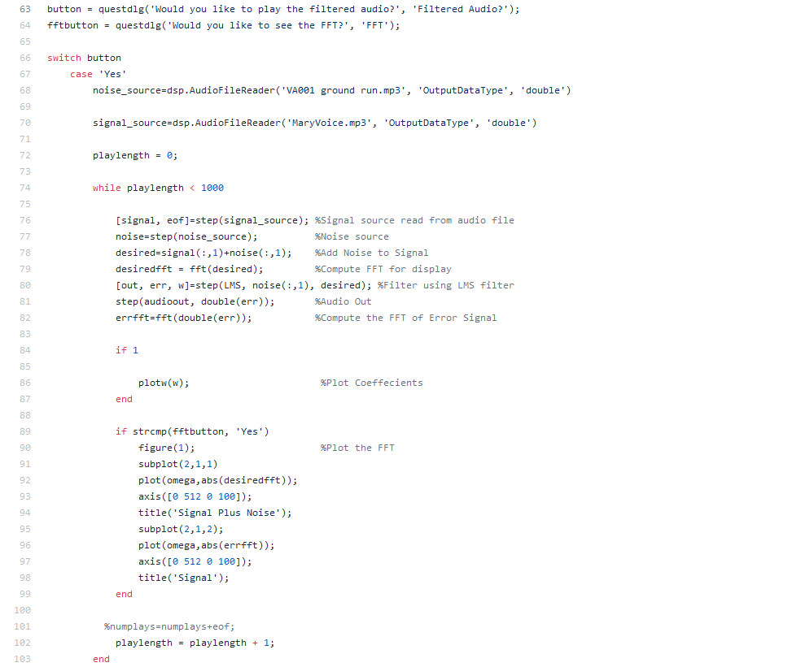

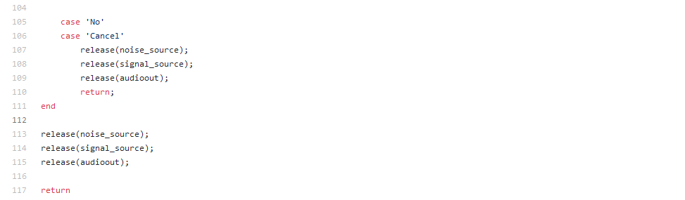

***Sound Recorder with Python***

Taking audio input was something new that I have never done before. The following code snippet is about how to record sound track in python in wav format. But this requires an additional python library in order to work with it.

Code Snippets:

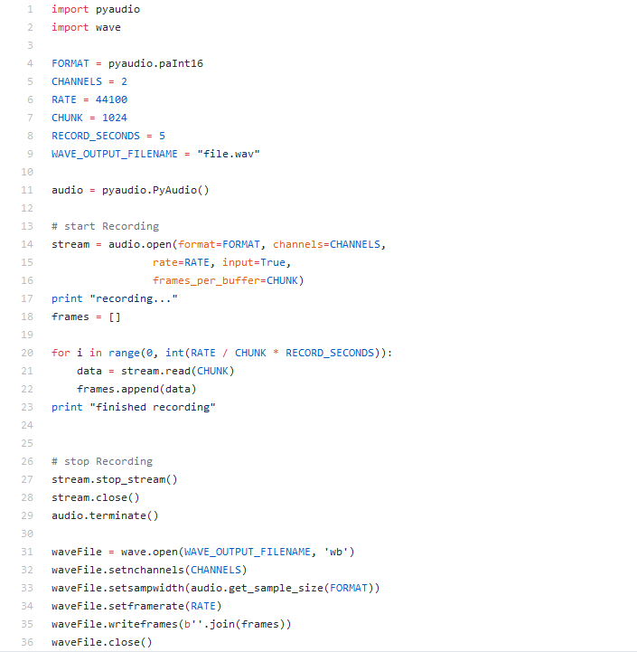

***Taking Multiple Audio Input (Microphone/s) and Plotting Graph in Real Time***

The final task of 499A was to do graph comparison in order to show each audio in a same environment doesn’t pick identical audio input. The following code snippet was done in python. It can plot graph in real time by taking one or multiple audio input and plot it into graph in real time. By looking at the graph we can do graph comparison which would help later on while continuing with the project work.

Code Snippets:

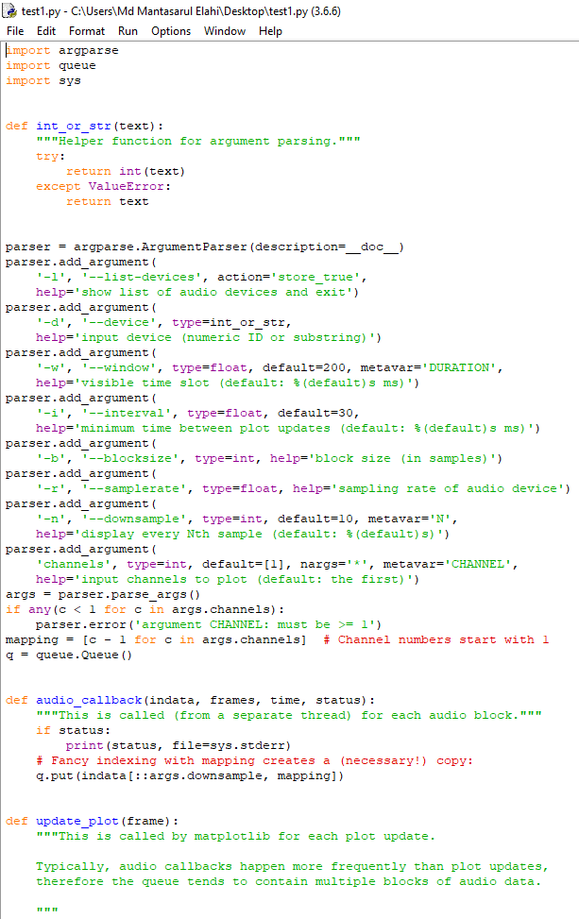

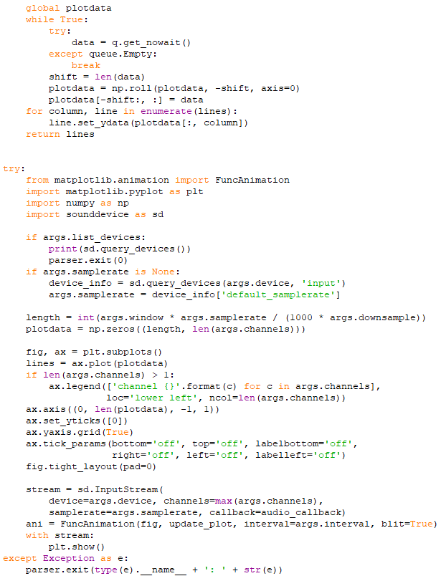

***Graph Output***

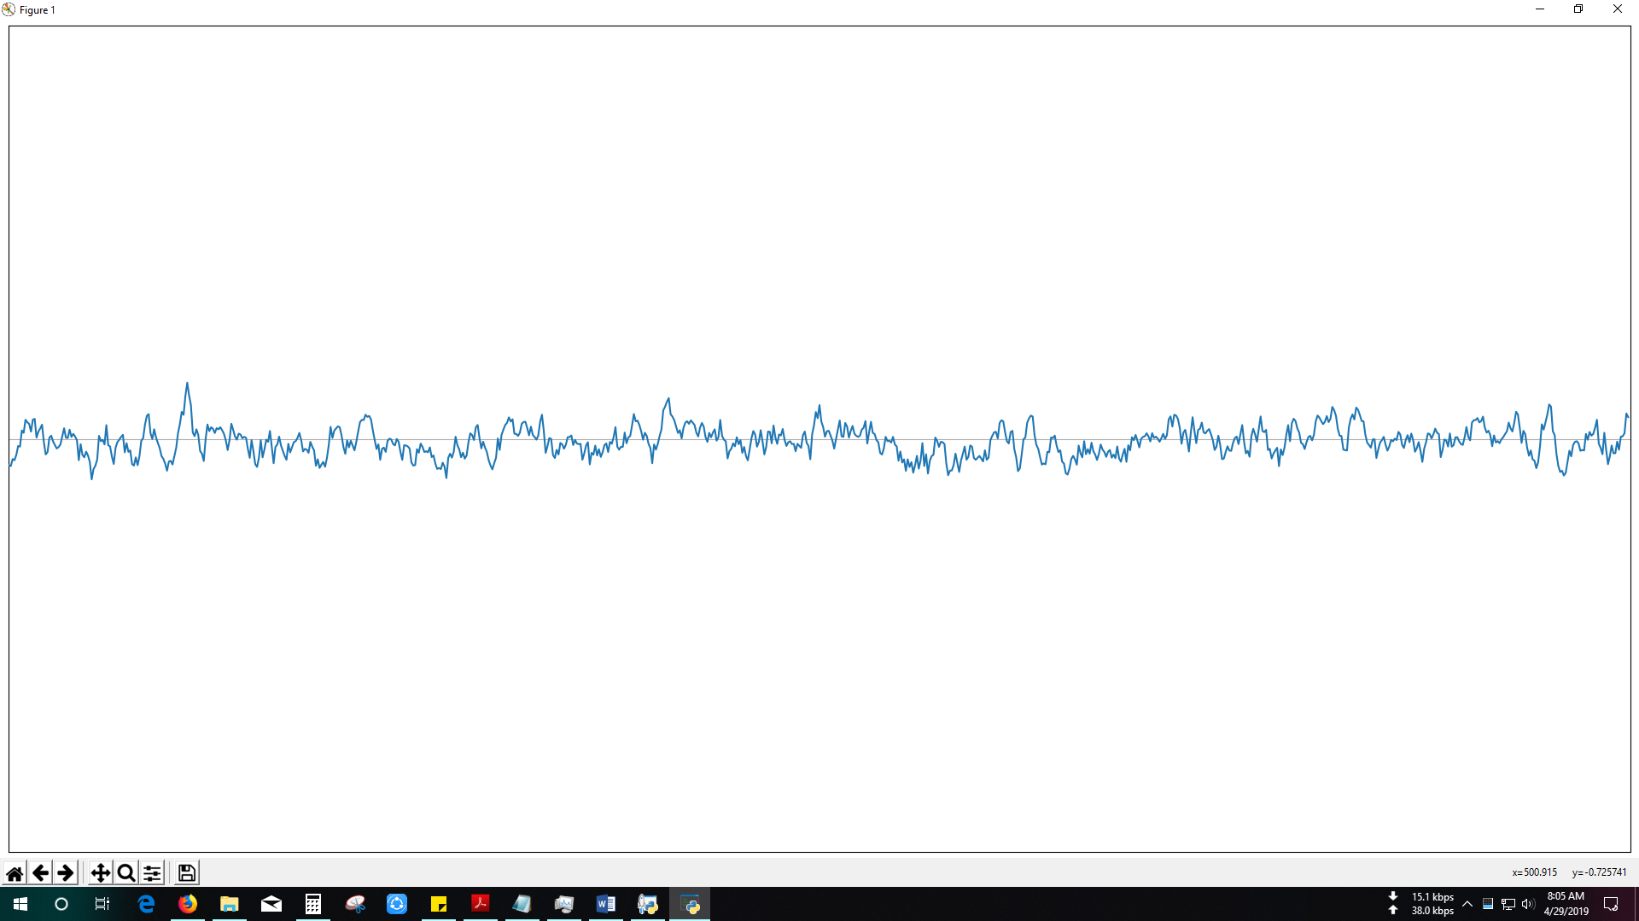

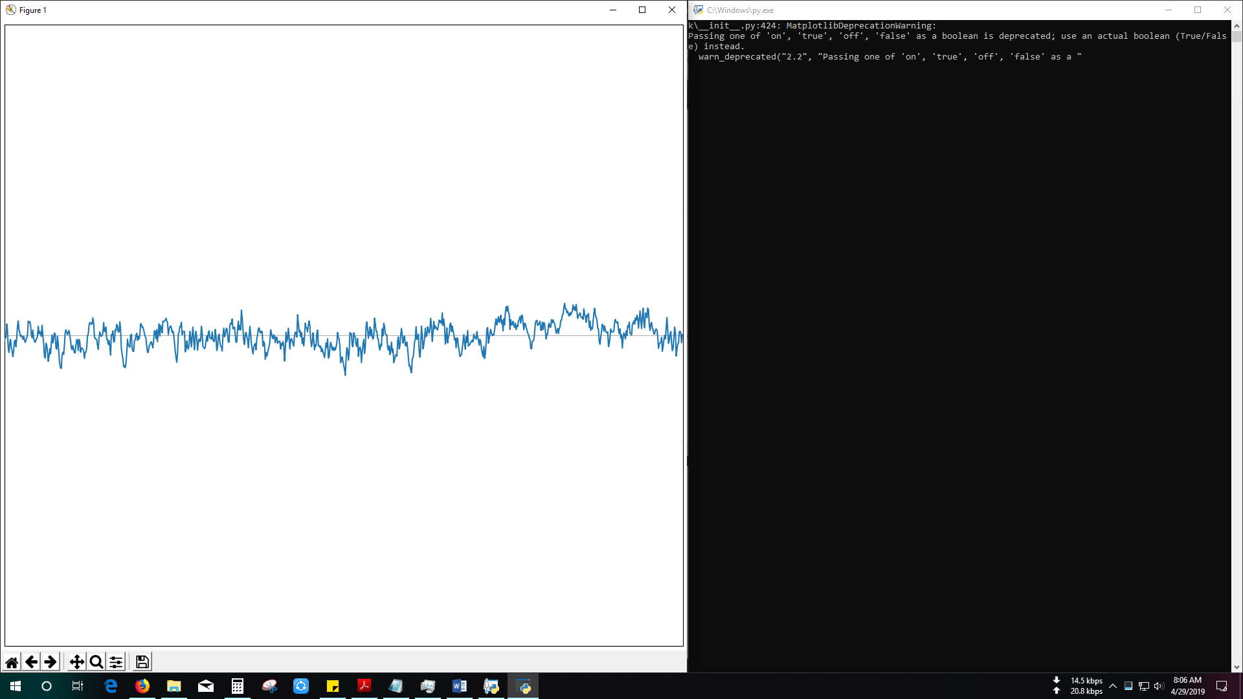

P.S. I didn’t have additional microphone so initially can’t show more than one output at a time.

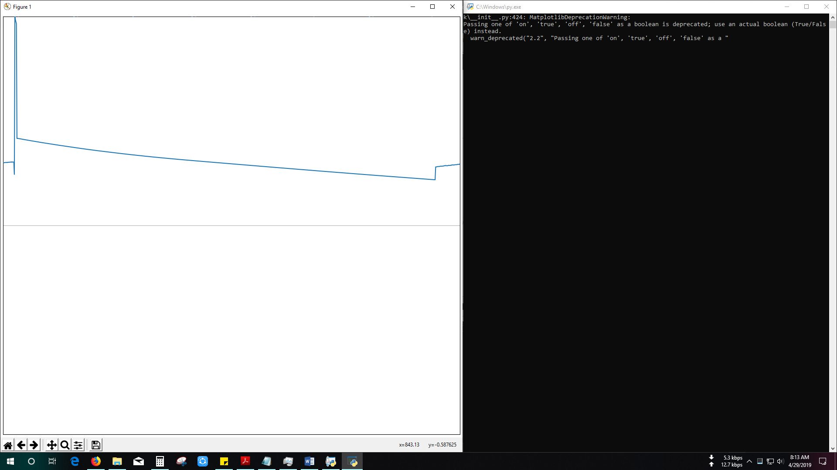

This diagram shows the output moment after the microphone was removed from the microphone port. The graph froze there and no change was seen.

Important Observation:

I did the execution of the program in my desktop. For desktop computers there are separate port for microphone and headphone. As I have used a mobile headphone which had a built-in microphone, I had to use a one input two output converter in order to use it in my desktop computer. When I have pulled off the headphone cord from the converter while the converter was still connected to my desktop, change in the frequency of the graph could be seen. If the converter is moved using hand (it was still connected to the pc), fluctuation in the graph could be seen. Later on when I finally pulled off the converter, the graph froze still with no change to the audio frequency.

Required Python Library List:

* Matplotlib
* Numpy
* Sound Device

***Audio Visualization in CMD using Basic Python***

Using simple Python code audio visualization could be done in CMD. For this python library sound device needs to be installed.

Code Snippets:

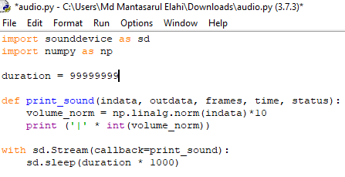

***Graph Output***

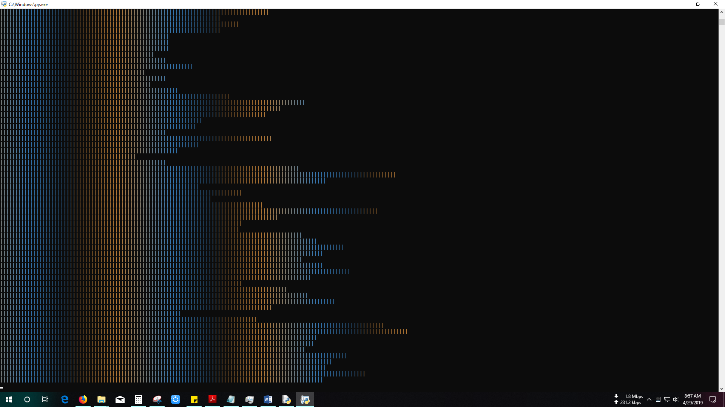

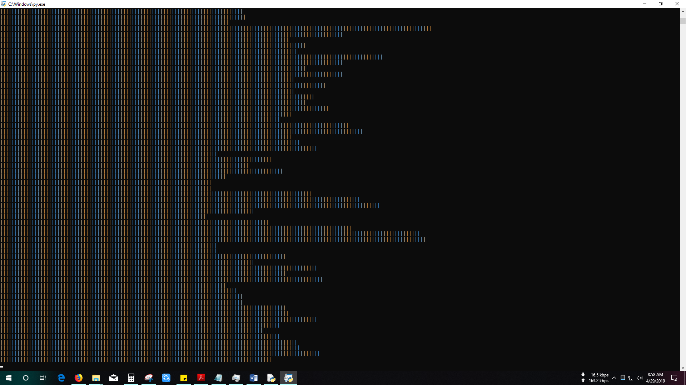

***Future Goal***

* Properly use all these resources and modify them when needed to get better expected result and carry out the research.
* Start building the Android application in order to use this research in the actual project

***Conclusion***

### Special thanks to Mohammad Ashrafuzzaman Khan for selecting my project idea which I never expected would get this much priority and for enlightening me in this interesting field of work and for all the opportunities.

### The End